Given the root of a binary tree, return *the length of the longest path, where each node in the path has the same value*. This path may or may not pass through the root.

**The length of the path** between two nodes is represented by the number of edges between them.

**Example 1:**

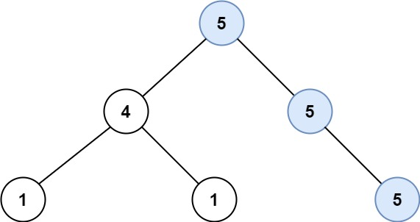

Input: root = [5,4,5,1,1,null,5]  
Output: 2  
Explanation: The shown image shows that the longest path of the same value (i.e. 5).

**Example 2:**

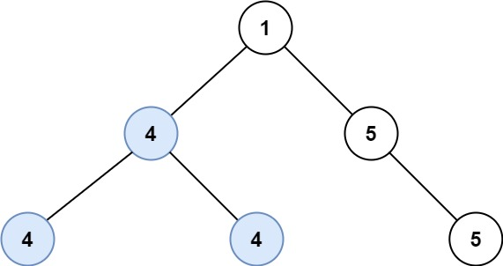

Input: root = [1,4,5,4,4,null,5]  
Output: 2  
Explanation: The shown image shows that the longest path of the same value (i.e. 4).

**Constraints:**

* The number of nodes in the tree is in the range [0, 104].
* -1000 <= Node.val <= 1000
* The depth of the tree will not exceed 1000.